## Understanding the Seasons

The Earth experiences four main seasons: Spring, Summer, Autumn (or Fall), and Winter. Why do we have these seasons? The answer is more complicated than you may think!

### Earth’s Tilt is the Reason

The primary reason for the seasons is the tilt of the Earth’s axis. The Earth’s axis is tilted at an angle of about 23.5 degrees relative to its orbit around the Sun.

#### How it Works

As the Earth orbits the Sun, the North Pole points slightly towards the Sun for half of the year, and for the other half of the year, it points slightly away from the Sun.

Summer: When a part of the Earth is tilted **towards** the Sun, it receives more **direct** sunlight and for a **longer** part of the day. This increased and direct sunlight results in warmer temperatures, making it summer **for that hemisphere**.

Winter: Conversely, when a part of the Earth is tilted **away** from the Sun, it receives **less** direct sunlight and for a **shorter** part of the day. This results in cooler temperatures, making it winter **for that hemisphere**.

Spring and Autumn: In between, when the tilt is neither towards nor away from the Sun, we experience spring and autumn. During these seasons, the temperatures are moderate.

**Test your understanding**: You should be able to explain to someone why when one hemisphere experiences summer the other hemisphere experiences winter.

## Equinoxes and Solstices

The points in the Earth’s orbit where the tilt of the Earth’s axis is directly towards or away from the Sun are called **solstices**. These occur around June 21 (summer solstice in the Northern Hemisphere) and December 21 (winter solstice in the Northern Hemisphere). These are the longest days (summer solstice) or longest nights (winter solstice).

The points in the Earth’s orbit where the tilt of the Earth’s axis is neither towards nor away from the Sun are called **equinoxes**. These usually occur around March 21 (spring equinox) and September 21 (autumnal equinox). On these days, day and night are of approximately equal length all over the planet.

Remember, the seasons are reversed in the Northern and Southern Hemispheres. So when it’s summer in the Northern Hemisphere, it’s winter in the Southern Hemisphere, and vice versa.

## Terms

**Rotation**: This is the spinning of the Earth on its axis. One rotation takes about 24 hours and gives us day and night.

**Revolution**: This is the movement of the Earth around the Sun. One revolution takes about 365.25 days, which is one year.

**Axial Tilt (or tilt of the Earth’s axis)**: This is the angle between the Earth’s rotational axis and its orbital plane (the ecliptic). It’s about 23.5 degrees and is responsible for the change in seasons.

**Perihelion**: This is the point in the Earth’s orbit where it is closest to the Sun. It usually occurs around January 3rd each year. (It has nothing to do with the cause of the seasons.)

**Aphelion**: This is the point in the Earth’s orbit where it is farthest from the Sun. It usually occurs around July 4th each year. (It has nothing to do with the cause of the seasons.)

**Equinox**: This is the point in the Earth’s orbit where the tilt of the Earth’s axis is neither towards nor away from the Sun, resulting in nearly equal day and night. It occurs around March 21 (spring equinox) and September 21 (autumnal equinox).

**Solstice**: This is the point in the Earth’s orbit where the tilt of the Earth’s axis is directly towards or away from the Sun. It occurs around June 21 (summer solstice in the Northern Hemisphere) and December 21 (winter solstice in the Northern Hemisphere).

**Ecliptic**: This is the plane of Earth’s orbit around the Sun. The Earth’s axis is tilted relative to the ecliptic.

## Understanding the Moon’s Phases

The Moon doesn’t shine its own light, but we can see it because it reflects the Sun’s light. As the Moon orbits the Earth, we see different parts of the Moon lit up by the Sun. These are the phases of the Moon.

### New Moon

The New Moon is the first phase of the Moon. During this phase, the Moon is between the Earth and the Sun, so we can’t see the side of the Moon that is lit by the Sun. (This is Rosh Chodesh.)

### Waxing Crescent

After the New Moon, the Moon moves a bit, and we start to see a small sliver of the Moon lit by the Sun. This phase is called the Waxing Crescent.

### First Quarter

As the Moon continues to move, we see half of the Moon’s face lit up. The Moon is one-quarter of the way through its cycle. The Moon will be overhead during Sunset during this phase.

### Waxing Gibbous

After the First Quarter, more than half of the Moon’s face is lit up but it’s not fully lit yet. This phase is called the Waxing Gibbous.

### Full Moon

When the Moon is on the opposite side of the Earth from the Sun, the entire side of the Moon we can see is lit up. This is the Full Moon. The Full Moon rises during Sunset and sets during Sun rise.

### Waning Gibbous

After the Full Moon, the Moon starts to move back towards the New Moon phase. The lit part of the Moon starts to shrink. This phase is the Waning Gibbous.

### Third Quarter

When half of the Moon is lit up again, but the lit part is shrinking, this is the Third Quarter phase. The Moon is highest in the sky during sunrise during this phase.

### Waning Crescent

Finally, just a small sliver of the Moon is lit up. This is the Waning Crescent phase. After this, the Moon will move back to the New Moon phase and the cycle starts again.

## Understanding Eclipses

Eclipses are fascinating celestial events that occur when the Sun, Earth, and Moon geometrically align. There are two types of eclipses: Solar Eclipses and Lunar Eclipses.

### Solar Eclipses

A Solar Eclipse happens when the Moon moves between the Earth and the Sun, blocking the Sun’s light. There are three types of solar eclipses:

**Total Solar Eclipse**: This occurs when the Moon completely covers the Sun. Observers within the path of totality (a narrow track along the Earth’s surface) will see the Sun completely blocked by the Moon. The sky darkens for a few minutes as if it were night.

**Partial Solar Eclipse**: This happens when the Moon only partially covers the Sun. The Sun appears to have a dark shadow on only a part of its surface.

**Annular Solar Eclipse**: This occurs when the Moon is too far from the Earth to completely cover the Sun. This results in a ring of sunlight around the darkened Moon.

You should never look directly at the Sun without proper safety equipment, as it can damage your eyes.

## Lunar Eclipses

A Lunar Eclipse occurs when the Earth moves between the Sun and the Moon, and the Earth’s shadow falls on the Moon. There are two types of lunar eclipses:

**Total Lunar Eclipse**: This happens when the Earth’s shadow completely covers the Moon. (The Moon can appear red during a total lunar eclipse due to the way Earth’s atmosphere bends sunlight.)

**Partial Lunar Eclipse**: This occurs when only a part of the Moon enters the Earth’s shadow.

Unlike solar eclipses, lunar eclipses are safe to view with the naked eye. You just need a clear night.

Eclipses don’t happen every month because the Moon’s orbit is tilted relative to the Earth’s orbit.

## Terms:

**Moon Phases**: The different shapes of the illuminated part of the Moon that can be seen from Earth.

**Waxing**: The phases of the Moon when its illuminated area is increasing.

**Waning**: The phase of the Moon when its illuminated area is decreasing.

**Crescent**: The phase of the Moon when less than half of its face is illuminated.

**Quarter**: The phase of the Moon when half of its face is illuminated.

**Gibbous**: The phase of the Moon when more than half but not all of its face is illuminated.

**Full**: The phase of the Moon when its whole face is illuminated.

**Eclipse**: An event that occurs when an astronomical object is temporarily obscured, either by passing into the shadow of another body or by having another body pass between it and the viewer.

## The Solar System and the Nebular Theory

### The Solar System

Our Solar System consists of the Sun, eight planets, their moons, and a variety of smaller objects like asteroids and comets.

The eight planets are divided into two main groups:

**Inner Planets**: These are the four planets closest to the Sun: Mercury, Venus, Earth, and Mars. They are also known as **terrestrial planets** because they have solid, rocky surfaces (terra meaning ground).

**Outer Planets**: These are the four planets furthest from the Sun: Jupiter, Saturn, Uranus, and Neptune. They are also known as **gas giants** (Jupiter and Saturn) and **ice giants** (Uranus and Neptune) due to their compositions or collectively as Jovian Planets.

### The Nebular Theory

The Nebular Theory is the most widely accepted explanation for the formation of the Solar System. According to this theory, the Solar System formed about 4.6 billion years ago from a giant cloud of gas and dust, known as a nebula.

Here’s how it happened:

1. **Gravitational Collapse**: Something, perhaps the shockwave from a nearby supernova, triggered a part of the nebula to collapse under its own gravity. As it collapsed, it spun faster and flattened into a disk.
2. **Formation of the Sun**: The center of the disk got hotter and denser, eventually sparking nuclear fusion reactions and forming the Sun.
3. **Formation of Planets**: Solid particles started to stick together and form planetesimals. These planetesimals collided and combined to form planets. Closer to the Sun, the planets are rocky (terrestrial planets) because it is too hot for icy materials to condense and form solids. Farther from the Sun, ices were much more available as building materials. The line separating the two is called the “frost line.”
4. **Clearing the Disk**: Over time, most of the remaining gas and dust was either incorporated into the planets or blown away by the solar wind, leaving the relatively clear Solar System we see today. Jupiter and Saturn are thought to have been massive enough to gravitationally attract gases from the original solar nebula.

This is a simplified explanation. The exact processes and timescales are subjects of ongoing research.

### Terms

**Solar System**: The Sun and everything that orbits around it, including planets, moons, asteroids, comets, and other celestial bodies.

**Inner Planets (terrestrial planets)**: The four planets closest to the Sun: Mercury, Venus, Earth, and Mars. They are also known as terrestrial planets because they have solid, rocky surfaces.

**Outer Planets**: The four planets furthest from the Sun: Jupiter, Saturn, Uranus, and Neptune. They are also known as **gas giants** (Jupiter and Saturn) and **ice giants** (Uranus and Neptune) due to their compositions.

**Nebular Theory**: The most widely accepted explanation for the formation of the Solar System. It suggests that the Solar System formed from a large cloud of gas and dust, known as a nebula.

**Nebula**: A giant cloud of gas and dust in space. Nebulas are often the birthplaces of stars and planets.

**Gravitational Collapse**: The process by which an object collapses under its own gravity. In the context of the Nebular Theory, it refers to the collapse of a part of the nebula to form the Solar System.

**Planetesimals**: The building blocks of plants. They formed by collision and combination of solid particles in the early Solar System.

**Ices**: When we say “ices” for this unit, we are talking about volatile substances like water, methane, carbon dioxide, carbon monoxide, and ammonia. These are the solid building blocks of the outer solar system.

**Frost Line** (you might also hear Snow Line or Ice Line): This is an imaginary line in the protoplanetary disk (the disk of gas and dust from which the Solar System formed) beyond which it was cool enough for some gases to form into ice crystals. Closer to the Sun, it was too hot for these compounds to remain solid. The frost line is significant in the formation of the Solar System because it marked the boundary between the inner terrestrial planets and the outer gas and ice giants.

## The Life Cycle of Stars

By understanding the stellar life cycle, you’ll be able to appreciate the night sky in a whole new light. The initial mass of a star plays a crucial role in determining its life story, including the duration of each phase. So, the next time you look up at the night sky, remember, you’re not just seeing stars, you’re witnessing a very short snapshot of their story.

**The Birth of a Star**

Stars begin their lives in a **Nebula**, a large cloud of dust and gas in space. Over time, gravity pulls the dust and gas together to form a **Protostar**. As the protostar gathers more material, its core’s temperature and pressure increase until nuclear fusion begins, marking the birth of a star. (We went over this process while talking about Nebular Theory of Solar System Formation.)

***The initial mass of the star at this stage will determine its entire life cycle.***

**The Prime of Life**

The star then enters the **Main Sequence** stage, which is the longest stage of a star’s life. During this stage, the star burns hydrogen in its core, releasing energy in the form of light and heat. The Sun remains in this stage for about 10 billion years, while stars of higher mass have shorter main sequence lifetimes (as short as 10 million years), and stars of lower mass have longer main sequence lifetimes (theoretically, as long as 100 billion years, but the Universe is only 13 billion years old).

**The Twilight Years**

As the star exhausts its hydrogen fuel, stars like the Sun will begin fusion of helium in its core, with a shell of hydrogen fusion around it. At this point, its surface expands (a lot) and cools, becoming a **Red Giant** or a **Supergiant**. These stars are very luminous due to their large size, but their surface temperatures are lower, giving them a reddish color. This phase lasts a few million to a billion years, depending on the initial mass of the star.

For stars more massive than the Sun, more and more elements will be fusing in the core and shells around the star, until the core forms iron.

**The Final Stages**

Eventually, the star will exhaust all its fuel. What happens next depends on the star’s initial mass. Low to medium mass stars, like our Sun, shed their outer layers (through winds) and leave behind a hot, dense core known as a **White Dwarf**. These stars cool down over billions of years.

High mass stars, on the other hand, after forming an iron core, will explode in a **Supernova**, leaving behind either a super-dense **Neutron Star** or a **Black Hole**, a region of space where gravity is so strong that nothing, not even light, can escape.

## Terms

* **Stellar Evolution** (or the stellar life cycle): The process by which a star changes over the course of time.
* **Nebula**: A large cloud of dust and gas in space where stars are born.
* **Protostar**: An early stage in the formation of a star resulting from the gravitational collapse of gases within a nebula.
* **Main Sequence Sta**r: A star that is in the longest stage of its life, during which it burns hydrogen in its core. These stars have temperatures ranging from 3,000 to 50,000 Kelvin and their luminosity varies greatly.
* **Red Giant/Supergiant**: A star that has exhausted the hydrogen in its core and has begun to expand and cool, causing its surface to become ‘red’. These stars have surface temperatures between 3,000 and 4,000 Kelvin and are very luminous due to their large size.
* **White Dwarf**: The remains of a star that has exhausted all its fuel for nuclear fusion and has expelled its outer layers. These stars are very hot, with surface temperatures ranging from 8,000 to 40,000 Kelvin, but are not very luminous.
* **Neutron Star**: The collapsed core of a large star, which is incredibly dense. These stars are extremely hot, with surface temperatures of up to 1 million Kelvin, but are not very luminous due to their small size.
* **Black Hole**: A region of space where gravity is so strong that nothing, not even light, can escape from it. Black holes do not have a surface and therefore do not have a surface temperature or luminosity in the traditional sense.
* **Supernova**: A powerful explosion that occurs when a star has used up its nuclear fuel and collapses under its own gravity. The temperature and luminosity of a supernova can exceed that of its parent star, but this is only temporary.
* **Luminosity**: The total amount of electromagnetic energy (light) emitted. The value does not depend on the distance to the observer.
* **Brightness**: The amount of electromagnetic energy (light) that reaches some area. A star may be very luminous but not appear bright because it is very far away.

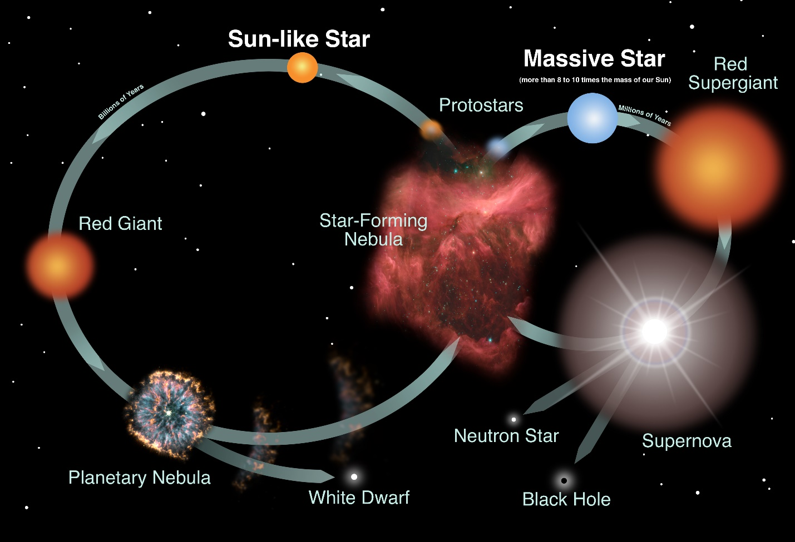

## Understanding the Big Bang Theory

Imagine everything you can see, everything you can touch, everything you know exists, all started from a single point. This is the central idea behind the **Big Bang Theory**, the leading explanation about how the universe began.

According to the Big Bang Theory, the universe started as a **singularity**, an incredibly hot and dense point. Then, in a fraction of a second, it underwent a rapid expansion known as **inflation**. During this period, the universe doubled in size at least 90 times!

As the universe expanded, it cooled. Within the first three minutes, protons and neutrons began to form. These particles came together to form hydrogen and small amounts of helium, marking the formation of the first basic elements.

Over hundreds of millions of years, matter in the universe began to clump together under the influence of gravity, forming stars and galaxies. This marked the beginning of the universe as we know it today.

## Understanding the Structure of the Universe

**Universe**: The universe is all of space and time and their contents, including planets, stars, galaxies, and all other forms of matter and energy.

**Galaxies**: Galaxies are like the building blocks of the universe. They are large systems of stars, gas, dust, and dark matter bound together by gravity. There are different types of galaxies, including spiral, elliptical, and irregular galaxies. Our home galaxy, the Milky Way, is a spiral galaxy.

**Local Group**: The Local Group is the galaxy group that includes our Milky Way. It comprises more than 54 galaxies, most of them are small, irregular galaxies. The two most massive galaxies in this group are the Milky Way and the Andromeda Galaxy.

**Galaxy Clusters**: Galaxy clusters are large collections of galaxies. Each cluster can have hundreds to thousands of galaxies. They are some of the largest structures in the universe held together by gravity.

**Local Cluster**: The Local Cluster, also known as the Virgo Cluster, is the galaxy cluster that is closest to our Local Group. It contains about 1300 to 2000 galaxies.

**Superclusters**: Superclusters are massive structures that consist of multiple galaxy clusters, groups, and individual galaxies. They are some of the largest known structures in the universe.

**Laniakea Supercluster**: The Laniakea Supercluster is the supercluster that is home to our Milky Way galaxy and approximately 100,000 other nearby galaxies.

## Understanding Galaxies

A **galaxy** is a large system of stars, gas, dust, and dark matter gravitationally bound together. There are different types of galaxies, including spiral, elliptical, and irregular galaxies. Our home galaxy, the Milky Way, is a barred spiral galaxy. Galaxies come in many shapes and sizes, astronomers categorize them as spiral, elliptical, or irregular.

Elliptical galaxies are likely the final remnant of many mergers of galaxies. These galaxies are no longer forming stars.

Spiral galaxies have lots of gas and dust and active star formations.

Irregular galaxies are probably the result of some major gravitational interaction. They are also often forming stars.

## Terms

1. **Big Bang Theory**: The leading explanation about how the universe began at a single point and expanded over billions of years to its current state.
2. **Galaxy**: A large system of stars, gas, dust, gravitationally bound together.
3. **Milky Way**: Our home galaxy, which is a spiral galaxy.